- Write a procedure that computes the perimeter and the area of a
rectangle. Define your own values for the length and width. (Assuming
that L and W are the length and width of the rectangle,
Perimeter = 2*(L+W) and Area = L*W. 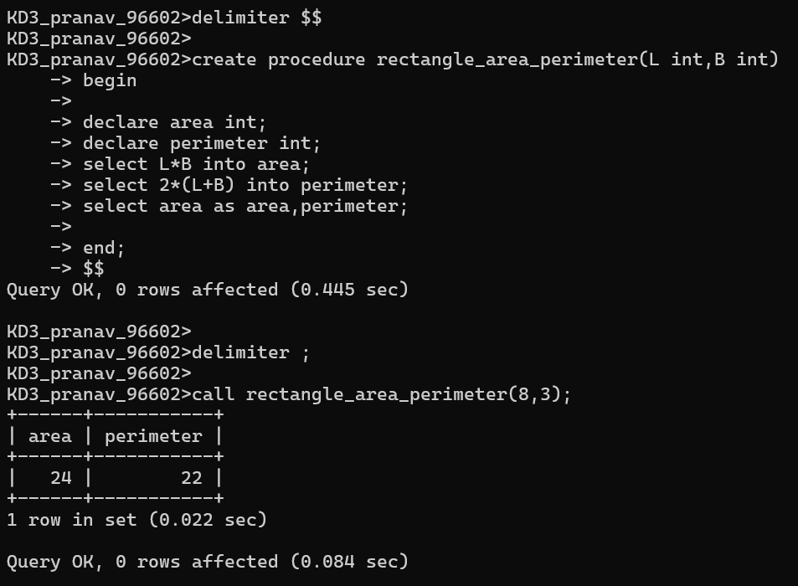

2. Write a procedure that declares an integer variable called num, assigns
a value to it, computes and inserts into the temp table the value of the
variable itself, its square, and its cube. 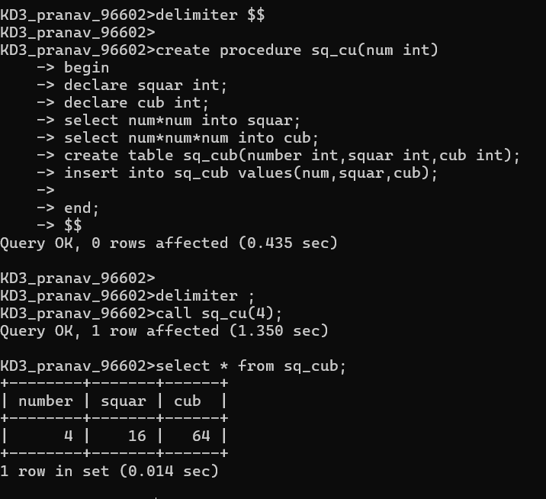

3. Create a procedure to Convert a temperature in Fahrenheit (F) to its
equivalent in Celsius (C) and vice versa. The required formulae are
C= (F-32) *5/9 F= 9/5*C + 32
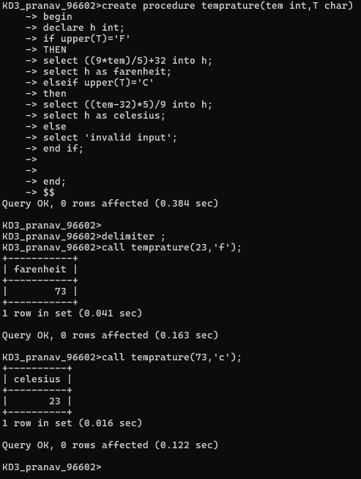

4. Create a procedure to Convert a number of inches into yards, feet, and
inches. For example, 124 inches equals 3 yards, 1 foot, and 4 inches. 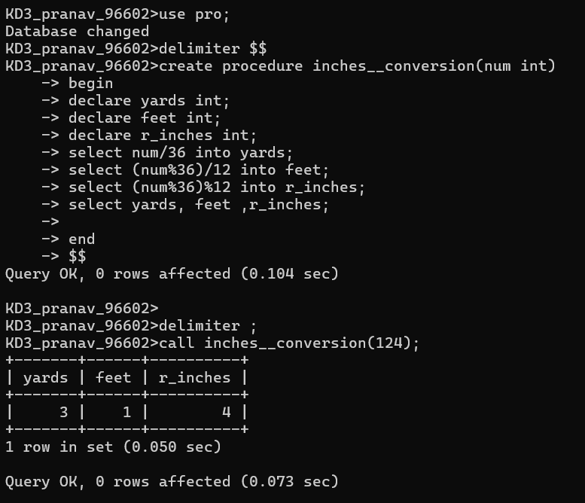

5. Create a procedure to read two real numbers and tell whether the
product of the two numbers is equal to or greater than 100. 